

TOM Integration

Interface Specification
For
Stock Take Result

STORELINE
To
GFO

[D029 to D022]

Project BEN Code: | W60416
Author: | Debasis Pattanaik
Date: | 02/04/2007
Version: | 1.1
Status: | Signed-Off
Modified By:
Reviewed By: | Erwin Oguz

Change Record

Author | Date | Version | Change Reference, description
Debasis Pattanaik | 09/02/2007 | 0.1D | Draft
Ganesan, Sankar | 12/02/2007 | 0.1D | Draft
Debasis Pattanaik | 13/02/2007 | 0.2D | Updated as per Erwin review comments
Debasis Pattanaik | 02/04/2007 | 1.1 | Signed Off – Incorporated DB2 specific Stored Proc by removing previously used COBOL formatted stored proc.

Reviewers

Name | Date | Version | Position
Ganesan, Sankar | 12/02/2007 | 0.1D | Draft
Erwin Oguz | 13/02/2007 | 1.0 | Sign-Off version

At least one reviewer is required.

Sign-Off

By signing this form, I understand and agree with the contents of this document.

Business Owner/Customer | Erwin Oguz
Position | Solution Architect
Signature
Date | 13/02/2007

Distribution List

Name | Date of Issue | Version
Oguz Erwin | 13/02/2007 | 1.0
David Onyett | 13/02/2007 | 1.0
Venkateswara Rao | 13/02/2007 | 1.0

Document Source

Related Documents: XML STORELINE source file schema, GFO system TSD document & STORELINE system FSD document

Directory: Embedded in this document.

File Name:
XML STORELINE source file schema - tes.jp.retail.storeline.stocktakeRequest.v2.2.xml

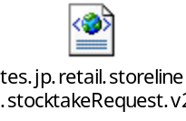

GFO system TSD document - TSD008 - Stock Record - non-sales events.doc

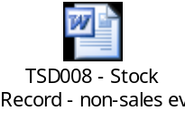

STORELINE system FSD document - FS1847_BO_Stock_Interfaces.doc

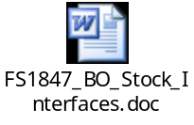

Information Architecture Context diagram
D022- Stock Take Result_Information_Context_Diagram.vsd
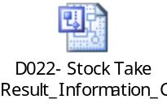

Mapping spreadsheet
Not required for this interface
Table of Contents
1 Introduction 7
1.1 Purpose of Document 7
1.2 Background 7
1.3 Scope 7
2 Description and Requirements for the End-to-End Interface 8
2.1 Description of the End-to-End Interface 8
2.2 Architecture 8
2.3 Requirements for the End-to-End Interface 9
3 Processing required in an Extract-Stage of the interface 10
3.1 Scope 10
3.2 Source Message Schema 10
3.3 Message Format 11
3.4 Message Transport Details 12
3.5 Naming and Configuration 12
3.6 Environment and Security Context 13
3.7 Non-Functional Requirements 13
4 Processing required in the Messaging Stage of the interface 14
4.1 Scope 14
4.2 Data Validation 14
4.3 Filtering 14
4.4 Stored Procedures 14
4.5 JH0S00 – Package to return STREAM info 14
4.6 JI0P13– process stock takes – new subroutine 14
4.7 Mapping 15
4.8 Mapping of JH0S00 – Package to return STREAM info 15
4.9 Mapping of JI0P13– process stock takes 16
4.10 Message Format 17
4.11 Message Transport Details 17
4.12 Naming and Configuration 18
4.13 Environment and Security Context 18
4.14 Non-Functional Requirements 18
5 Processing required in the <third stage of the interface> 19
5.1 Scope 19
5.2 Data Validation 19
5.3 Filtering 19
5.4 Mapping 19
5.5 Target Message Schema 19
5.6 Message Transport Details 19
5.7 Naming and Configuration 19
5.8 Environment and Security Context 19
5.9 Non-Functional Requirements 19
6 Testing Deliverables 20
7 Deployment 21
8 Assumptions and Outstanding Issues 22
8.1 Assumptions 22
8.2 Outstanding Issues 22
Appendix A Volumes 23
• Glossary 24
Appendix B Document Control 25

Introduction

Purpose of Document
The purpose of this document is to describe the interfacing requirements with respect to STORELINE interface (D029) Stock take result data updating into the GFO system interface (D022).

The document is of a sufficiently technical in nature to allow a developer to build an actual interface. Additionally the document contains detail that might sit logically within a Technical System Design (TSD) document, but is contained here for expediency. Therefore the GFO system Technical System Document (TSD) and STORELINE system Functional System Document are provided for better understanding of this interface.

This interface is only for US implementations. Turkey implementation does not require this interface.

Background
As part of Tesco Operating Model program, there is requirement to bridge the functionalities of enterprise applications including STORELINE and GFO. To achieve this functionality, high level process flow architecture has been designed and approved by Tesco’s Enterprise Architecture team. As part of this process flow architecture there is a set of interfaces that has been identified to be developed to transfer Stock take result data from STORELINE into GFO.

Scope
The Interface Specification covers:

- audit requirements across the interface
- security requirements across the interface
- timing/frequency requirements or constraints
- support requirements
- archiving
- the data format to be used for the interface at each stage (e.g. xml messages)
- the normal processing required at each stage
- recovery from failure required at each stage
- volumes.

Note that it is Tesco strategy to avoid placing any business logic in integration layer processing.

Description and Requirements for the End-to-End Interface

Description of the End-to-End Interface
The interface is to upload the Stock take result data from STORELINE interface D029 into GFO interface D022. The Upload is a full upload in nature.

The interface will be governed by BizTalk Orchestration, which expects the Stock take result data in (| delimited flat file) from STORELINE interface (D029). The STORELINE interface will put this file (*.dat) in the shared location through RTI SOAP adapter. The BizTalk server then transfers this flat file data by invoking GFO interface (D022) stored procedures through DB2 adopter. BizTalk will first invokes JH0S00– package return STREAM info - stored procedure to get the stream information which is passed along with other input attributes of JI0P13 – stored procedure to get updated/inserted in GFO underlying table. The output attributes returned by stored procedure will determine the success/failure of this updating.

The interface will make use of the audit and traceability components that are being developed as part of the Operational Framework stream. Developers should put a ‘placeholder’ in their code / configurations as appropriate.

Architecture
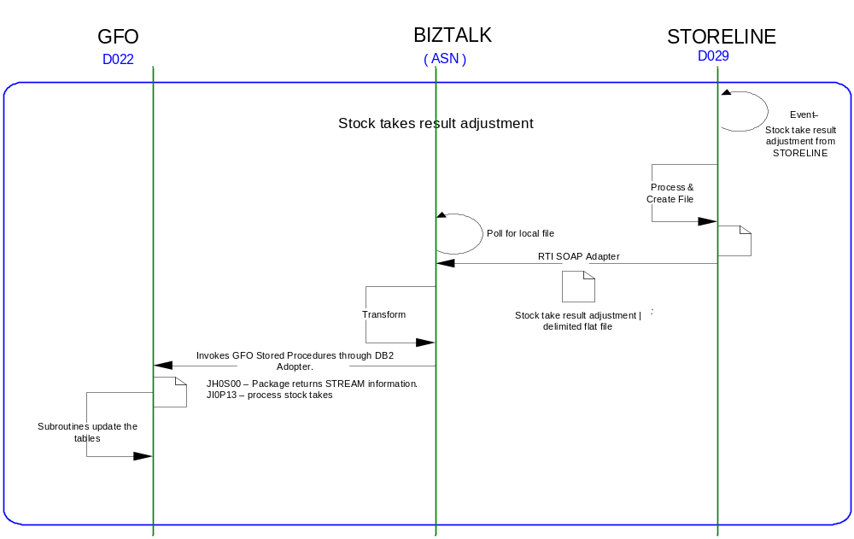

Requirements for the End-to-End Interface

Audit Requirements | The interface will use the components provided by the Operational Framework to satisfy audit requirements.
Security Requirements | The interface executes within a secure private domain. There are no additional security considerations required.
Timing/Cut-off Constraints | To be finalised.
Performance Requirements | The interface should be capable of extracting data in the form of flat file from the shared location at STORELINE side and delivering the resulting into GFO side database tables before the identified cut-off time. The interface should run on real time basis.
Reliability and Availability Requirements | The interface-run should be atomic in nature. Where it is not possible to implement an atomic nature of interface, appropriate mechanisms should be in place to raise/alert appropriate parties.
Scalability Requirements | N/A - No scalability issues exist.
Operational Support Requirements | No such requirement has been agreed upon at the time of writing this document. However, it is perceived that there would be interface support requirements after go-live date that would require an evaluation.
Likelihood of Change Requirements | There is no such requirement
Cultural/Global Consideration Requirements | N/A
Legal Requirements | N/A
Compliance To Standards Requirements | No compliance exceptions.

Processing required in an Extract-Stage of the interface

Scope
STORELINE creates a pipe | delimited flat file whenever stock take has been taken and put the file in a dedicated shared location. The flat file extension is *.dat and BizTalk in turn picks up the file from the shared location and invokes series of subroutines through DB2 Adopter to update/insert the underline table of GFO.

Source Message Schema
Field Name | Optional | Type | Description
HEADER RECORDS
CapturedBy-CreatedBy | Yes | string | Extract file created user name
DateOfExtract | Yes | date | Store-line extraction date
DelAfterDate | Yes | string | Delivery before date
DelBeforeDate | Yes | string | Delivery after date
Description | Yes | string | Free form description
DriversName-Courier | Yes | string | Courier Driver Name
InvoiceNumber | Yes | string | Invoice Number
InvoiceTaxTotal | Yes | ui8 | Invoice Tax Total
InvoiceTotal | Yes | ui8 | Invoice Total
NoOfDetailLines | Yes | ui8 | No. of Detail Items
OrderDate | Yes | string | Count Order Date
OrderNumber-TransactionNo | Yes | ui8 | Count Order Number
OrderType-CountType | Yes | ui8 | Count Order Type
OriginalOrderNumber | Yes | ui8 | Original Order Number
ReasonCode | Yes | string | Reason Code
RecordType | Yes | string | Record Type
RefNo1 | Yes | string | Reference No 1
RefNo2 | Yes | string | Reference No 2
Remarks | Yes | string | Remarks
ReProcessedFlag | Yes | string | Re-Processed Flag
SelectionCriteria | Yes | string | Criteria of selecting extract data
SelectionRange | Yes | string | Range of selecting extract data
StocktakeDueDate | Yes | string | Date when stock take taken
StoreAddress | Yes | string | Location Address
StoreName | Yes | string | Location Name
StoreNo | Yes | ui8 | Location of extracted data
SupplierAddress | Yes | string | Supplier Address
SupplierCode-ToStore | Yes | string | Supplier Code
SupplierName |  | string | Supplier Name
SupplierType |  | ui8 | Supplier Type
TimeOfExtract |  | time | Extraction time of data
TotalQty |  | ui8 | Total Quantity
TotalValue |  | ui8 | Total Value
TransactionDateTime |  | string | Transaction Date and Time
UserName |  | string | Operator Name
DETAIL RECORDS
CountQty | Yes | ui8 | Stock count Quantity
DateOfExtract |  | string | Extract date of data
InvoiceCost-Excl-PerUOM | Yes | ui8 | Invoice cost per UOM
InvoiceQty | Yes | ui8 | Invoice Quantity
ItemDescription | Yes | string | Description of Item
ItemNumber |  | ui8 | Item Number
LineNumber |  | ui8 | Record Line Number(Record starts from 1)
Location | Yes | string | Location of extract item
OrderNumber-TransactionNumber | Yes | ui8
OrderQuantity-SentQuantity | Yes | ui8
OrderType | Yes | ui8 | Order Type
PackSize-Ratio | Yes | ui8 | Item Pack size
ReasonCode | Yes | string | Reason code of Item
RecordType |  | string | Record Type
ReferenceNo | Yes | ui8 | Reference No
SellingPricePerUOM | Yes | ui8 | Selling price per UOM
Sign | Yes | string | Sign indicator  - negative  + positive
StoreNo |  | ui8 | Store Id
SupplierItemNo-CatalogueNo | Yes | string | Supplier Item No
TaxPercentageOnCost | Yes | ui8 | Tax percentage on Invoice Cost
TimeOfExtract |  | string | Time of Extract
TrsCostPrice-Excl-PerUOM | Yes | ui8 | Transaction cost value excluding per UOM
UOMCode | Yes | ui8 | Unit of measure details
UOMDescription | Yes | string | Unit of measure description

Message Format
The source message is in the form of pipe | delimited flat file from STORELINE.

Message Transport Details

Feature | Specification | Additional Information
Source System Name | STORELINE
Source Platform / OS | Windows
Source Physical Location
Source Underlying Data Storage Technology | SQL Server
Target System Name | Biztalk 2006
Target Platform / OS | Biztalk 2006 Server/Window Server 2003
Target Physical Location
Target Underlying Data Storage Technology | File Share
Transfer Function | HTTP (Put/Post) □  HTTPS (Put/Post) □  Message Queue □  FTP □  File Drop(Windows) ☑  (XCOM) □
Data Format. | XML □  Delimited ☑  Positional □ | | delimited
Decryption/Encryption | No
Decompression/Compression | No
Transmission Mode | Synchronous □  Asynchronous ☑  Bulk Data □
Real-time/Scheduled Batch | Not yet decided
Archiving | There is no requirement to archive the messages.
Logging | Logging should occur, such that the message can be recreated if necessary.
Error Handling | Not yet decided  Processing should prevent sending of duplicate messages, unless this occurs during recovery from failure.

Naming and Configuration

Biztalk – 2006
Package Name: TOM.D029toD022.StockTake.STORELINEtoGFO
BizTalk Procedure
Name | TOM.D029toD022.StockTake.STORELINEtoGFO
<Placeholder for other package components/steps>
<Placeholder for other package components/steps>

The naming standard to be followed as mentioned in this document –

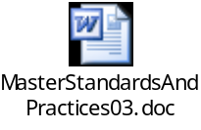

Environment and Security Context
Account details will be included here once we have visibility of the environments.

Non-Functional Requirements
Not Applicable

Processing required in the Messaging Stage of the interface

Scope
The BizTalk server transfers the source message schema file to GFO by invoking a series of stored procedures within DB2.This will first invokes JH0S00– stored procedure by taking Store No as input attributes- to get the stream information as output parameter which is passed along with other input attributes of JI0P13 stored procedure to get updated/inserted in GFO underlying table.

Data Validation
Data Validation will be done by the target GFO system.

Filtering
There is no filtering requirement.

Stored Procedures
The stock event data from STORELINE then immediately use it to invoke the relevant stored procedure(s) within DB2. The types of stock event involved are:

- Stock takes

The following description gives the details of stored procedure need to be invoked to pass data from STORELINE to GFO.

JH0S00 – Package to return STREAM info
JIP00 will determine a store’s database stream then point subsequent processing to that package set.

JI0P13– process stock takes – new subroutine
JI0P13 will take stock take data and use it to update the following tables:

TXJJ0ASC applied stock count
TXJJ0PPH product profile history
TXJJ0BKS stock record (via module JJ003D)

STORELINE Reason Code 314 = stock count (absolute)

Mapping
The STORELINE Stock take ROWSET get created by BizTalk and passed to GFO subroutines as input attributes. The input attribute order with its source mapping are given below,

Mapping of JH0S00 – Package to return STREAM info
The stored-procedure returns the STREAM field details. The input attribute to this store procedure is STORE ID which returns stream details and will be used with other store procedure as an input attributes. The foot-print of this stored procedure given below

Sr No | Attribute Field Name | Format | Source Field Type | Source  Field Name | Description
INPUT ATTRIBUTES
1 | IN_RO_NO | DECIMAL(5 , 0) | SetDtl | Store No | I/P attributes to stored procedure.
OUTPUT ATTRIBUTES
1 | OUT_STREAM | CHARACTER(1) |  |  | Stream Name(requires to be used in following stored procedures)
2 | OUT_CODE_LEVEL | CHARACTER(1)
3 | OUT_CR_PART_NO | CHARACTER(2)
4 | OUT_RO_NAME | CHARACTER(25) |  |  | Store Name
5 | OUT_ERROR_CODE | DECIMAL(2 , 0) |  |  | Contains the return code to indicate the success or failure of the call
6 | OUT_ERROR_LOG | CHARACTER(29) |  |  | Contains some simple diagnostics of the programme causing a fatal error

The return output attributes determine the success/failure of data insert/update in GFO e.g.

0 - successful update
1 - System unavailable
4 - Store not found
5 - Steam invalid
6 - Fatal error
8 - Code level invalid

In either cases the message need to be written on event log. In case of failure the subscription message get suspended but remain in disposable mode which keeps on trying to get success stream information from stored procedure to execute subsequent stored procedure. The failures of this stored procedure also stop execution of following stored procedure and move to next ROWSET.

In case of failure a log file has to be maintained as per the format given below e.g.

< Source File Name >. < Store Procedure Name >. < Processed DATE/TIME > - < OUT_ERROR_CODE > - < OUT_ERROR_LOG >

Mapping of JI0P13– process stock takes
The foot-print of this stored procedure with its ROWSET mapping details are given below –

Sr No | Attribute Field Name | Cobol Format | Source Field Type | Source  Field Name | Description
INPUT ATTRIBUTES
1 | IN_STREAM | CHARACTER(1) |  |  | Output attribute of JH0S00 Stored Procedure
2 | IN_RO_NO | CHARACTER(5) | SetDtl | Store No | Store id comes from source schema
3 | IN_APPLIC_CD | CHARACTER(8) |  |  | It is a unique application identifier. Set to “D029D022”
4 | IN_APP_DATETIME | CHARACTER(23) |  |  | It is the timestamp of when the calling application called. It will have the Format: yyyy-mm-dd-hh:mm:ss:ttt
5 | IN_BPR_TPN | CHARACTER(9) | SetDtl | Item Number | Item number on which stock take has been taken
6 | IN_COUNT_DATE | CHARACTER(10) | SetDtl | Date of Extract | CCYY-MM-DD
7 | IN_COUNT_TIME | CHARACTER(8) | SetDtl | Time of Extract | HH.MM.SS
8 | IN_QUANTITY | CHARACTER(7) | SetDtl | Count Qty | Stock takes quantity
OUTPUT ATTRIBUTES
1 | OUT_ERROR_CODE. | DECIMAL(4 , 0) |  |  | Returned ZERO in case of success
2 | OUT_ERROR_LOG | CHARACTER(29)

The return output attributes determine the success/failure of data insert/update in GFO.In either cases the message need to be written on event log. In case of failure a log file has to be maintained as per the format given below e.g.

<Source File Name>.<Store Procedure Name>. <Processed DATE/TIME> . < OUT_ERROR_CODE > - < OUT_ERROR_LOG >

Message Format

Message Transport Details
For messages destined for GFO system, the following applies.

Feature | Specification | Additional Information
Source System Name | Biztalk 2006
Source Platform / OS | Biztalk 2006 Server/Windows Server 2003
Source Physical Location
Source Underlying Data Storage Technology | File System
Target System Name | GFO
Target Platform / OS | COBOL/UNIX
Target Physical Location
Target Underlying Data Storage Technology | RDBMS
Transfer Function | HTTP (Put/Post □  HTTPS (Put/Post) □  Message Queue □  FTP □  File Drop (Windows) □  (XCOM) □  RTI File Adapter □  DB2 Adapter ☑
Data Format | XML □  Delimited □  Positional □  COBOL format ☑
Decryption/Encryption | No
Decompression/Compression | No
Transmission Mode | Synchronous □  Asynchronous ☑  Bulk Data □
Real-time/Scheduled Batch | Real-time
Archiving | There is no archiving requirement
Logging  Should logs be kept of all actions? For how long should these be stored? | Logging should occur, such that the message can be recreated if necessary.
Error Handling | Not yet decided  Processing should prevent sending of duplicate messages, unless this occurs during recovery from failure.  Currently it will keep all error details in a txt file. Later this may change as per the business decision.

Naming and Configuration

Biztalk 2006
Instruction Name:
Instruction Details
Description | To be determined
Enabled | True
Type
Operational Window
Schedule | N/A
Enabled | False
Host Details
Account | To be determined
Operational Details
Worker Threads
Priority
Batch Size
Period
Retry Attempts
Timeout
Require Data Send
Exception Management
Treat Fatal Adapter Exception As
Treat Unhandled Exceptions As

Environment and Security Context
Account details will be included here once we have visibility of the environments.

Non-Functional Requirements
On successful delivery of the file to the target system, the audit log should be updated via the Operational Framework pipeline component or adapter (to be determined).

In the event of a failure the file should be written to the failed files location, and an alert should be raised.

Processing required in the <third stage of the interface>

Scope
There is no intermediate staging is required for this interface. So this section is not applicable.

Data Validation
Not Required

Filtering
Not Required

Mapping
Not Required

Target Message Schema
Not Required

Message Transport Details
Not Required

Naming and Configuration
Not Required

Environment and Security Context
Not Required

Non-Functional Requirements

Not Required

Testing Deliverables
Unit Test Scripts and test cases are kept at the following location <location>

Deployment

Assumptions and Outstanding Issues

Assumptions
ID | Assumption
1 | Rollback transaction supported by GFO in case of failure.
2 | Assuming STREAM information is extracted from JH0S00 stored procedure through DB2 adopter for each input ROWSET.

Outstanding Issues
ID | Issue | To be addressed by
1 | DB2 adopter specification to call sub procedures need to be defined | Erwin Oguz
2 | Error handling with respect to DB2 copybook need to be defined | Erwin Oguz
3 | Error log file location need to de defined | Erwin Oguz
4 | STORELINE source file Physical Location need to be defined | Erwin Oguz

- Volumes
- Glossary

Acronym | Term | Description
EAI | Enterprise Application Integration | The process of meeting the data requirements of applications by providing a message based transport from disparate data sources across all forms of enterprise technology.
EAI Layer | Enterprise Application Integration Layer | Refers to the integration services provided to implement EAI. In contrast to the EIA Layer for data services. See below.
EIA | Enterprise Information Architecture | Creation of a strategic single view of data across the enterprise.
Interface | Interface | Many definitions exist for 'interface'. In general, 'interface' refers to the link between a data source and a data target. And there are properties of the interface in this context. However more specifically 'interface' refers to one end of a data link, hence the terms source interface and target interface, and both the source interface and the target interface will have specific properties of their own.
GFO | Group Forecasting and Ordering | The GFO operates on Tesco deals with the forecasting & Ordering.
STORELINE | STORE used for inventory purposes. | The STORELINE operates on Tesco deals with the inventory control.
XSD | XML Schema Definition | It describe the elements in an Extensible Markup Language (XML) document
XML | Extensible Markup Language | An open standard for describing data. It is used for defining a common method for identifying data. It supports business-to-business transactions and also uses electronic data interchange and Web services.
FTP | File Transfer Protocol | The Internet File Transfer Protocol (FTP) is defined facilities for transferring files to and from remote computer systems.
DB2 | Database access adopter | It is used to access AS/400 platform. This helps to invokes underlying database stored procedure from outside. It has capability to invoke stored procedure as per the ROWSET.

- Document Control
Change Record

Author | Date | Version | Change Reference, description
Debasis Pattanaik | 09/02/2007 | 0.1D | Draft
Ganesan, Sankar | 11/02/2007 | 0.1D | Draft
Debasis Pattanaik | 12/02/2007 | 0.2D | Draft – incorporating Erwin review comments.
Debasis Pattanaik | 02/04/2007 | 1.1 | Signed Off – Incorporated DB2 specific Stored Proc by removing previously used COBOL formatted stored proc.

Related Documents

Author | Date | Version | Title
Isaac | 18-Aug-2004 | 4.0 | StoreLine FS1847 – BO Stock Interfaces
Neil Williams | 26-Jan-2007 | 0.02 | Technical System Design - TSD008 Stock Record - non-sale events

Distribution

Name | Position | Approver/Contributor/Other
Erwin Oguz | Enterprise Architect | Approver
David Onyett | Project Leader
Venkateswara Rao | Offshore Co-ordinator

